**Gemma Models Overview**
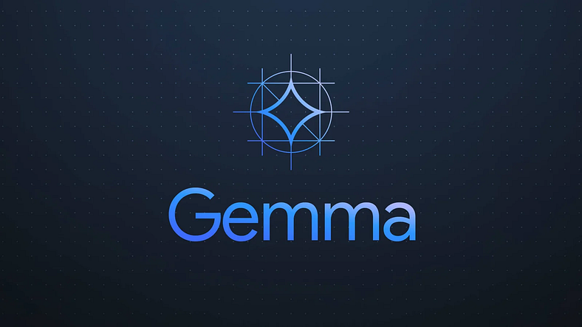
- Gemma is a family of lightweight, state-of-the-art open models derived from the same research and technology as the Gemini models.
- Developed by Google DeepMind and other teams across Google, Gemma emphasizes innovation, collaboration, and responsible AI usage.
- Named after the Latin word "gemma," meaning "precious stone," highlighting its value and quality.
"Lightweight" typically refers to something that is relatively small, compact, or consumes minimal resources, particularly in computing contexts. In the context of Gemma models, being "lightweight" suggests that they have a smaller size in terms of memory and computational requirements compared to larger, more complex models. This characteristic makes them easier to deploy and run on various hardware platforms, including mobile devices and low-power servers. It also implies that they may have faster inference times and lower overhead, making them more efficient for certain applications. Overall, being lightweight enables Gemma models to be more accessible and versatile for developers and users alike.
- **Availability and Customization: **
- Gemma models are accessible for deployment in various applications, including hardware, mobile devices, or hosted services.
- Developers can customize Gemma models using tuning techniques to enhance performance in specific tasks, offering tailored solutions to users.
- These models draw inspiration from the Gemini family and are designed for further extension and development by the AI community.
- **Text Generation and Specialization: **
- While Gemma models excel in text generation, they can be fine-tuned for specific tasks to provide more targeted and efficient AI solutions.
- Developers can explore tuning techniques, such as LoRA, to optimize Gemma models for particular applications, encouraging experimentation and innovation.
- **Model Sizes and Capabilities: **
- Gemma models come in different sizes, catering to varying computing resources and application requirements.
- The available parameter sizes include 2B and 7B, offering flexibility in deployment and capabilities based on needs.
- Platforms supported range from mobile devices and laptops to desktop computers and small servers, ensuring compatibility across different environments.
- **Using Gemma Models: **
- Leveraging the Keras 3.0 multi-backed feature, developers can run Gemma models on TensorFlow, JAX, and PyTorch, or utilize native implementations of JAX and PyTorch.
- Gemma models can be downloaded from Kaggle Models, providing easy access for developers to integrate them into their projects.
- **Tuned Models: **
- Gemma models can be further enhanced through model tuning, which involves additional training to improve performance in specific tasks.
- Tuning options include pretrained and instruction-tuned versions, with pretrained models serving as a base and instruction-tuned models capable of responding to conversational input, akin to a chat bot.
Considerations:
Limited Model Sizes: Currently, Gemma offers a smaller range of model sizes compared to some competitors. While this contributes to efficiency, it may restrict capabilities for highly complex tasks.
Newer Entrant: Compared to established models, Gemma is a relatively new player in the field. While promising, its long-term performance and feature development remain to be seen.
Focus on Text-to-Text Tasks: Gemma’s current focus is on text-to-text generation tasks. Integration with other NLP functionalities like sentiment analysis or question answering might require additional exploration.
Potential Applications:
Text Summarization: Gemma’s ability to generate concise and informative summaries can be valuable for processing large amounts of text data.
Chatbots & Virtual Assistants: By fine-tuning Gemma for dialogue generation, it can power chatbots and virtual assistants for more natural and engaging user interactions.
Machine Translation: While further exploration might be needed, Gemma’s text-to-text capabilities hold promise for machine translation applications, particularly for resource-constrained environments.
Code Generation & Analysis: With proper training, Gemma could assist developers by generating code snippets or analyzing existing code for potential issues.

Gemma models demonstrate strong performance across academic benchmarks for language understanding, reasoning, and safety. The team released two sizes of models (2 billion and 7 billion parameters), and provide both pretrained and fine-tuned checkpoints. It is claimed that Gemma outperforms similarly sized open models on 11 out of 18 text-based tasks, and this present comprehensive evaluations of safety and responsibility aspects of the models, alongside a detailed description of model development. There is belief that the responsible release of LLMs is critical for improving the safety of frontier models, and for enabling the next wave of LLM innovations.

To support developer innovation and responsible use, Google is also providing a Responsible Generative AI Toolkit alongside the models. This toolkit includes essential tools for creating safer AI applications with Gemma, offering guidance and support for developers.

To facilitate widespread adoption, Gemma is compatible with major frameworks, including JAX, PyTorch, and TensorFlow through native Keras 3.0. The release includes ready-to-use Colab and Kaggle notebooks, integration with popular tools such as Hugging Face, MaxText, NVIDIA NeMo, and TensorRT-LLM.

What is responsible AI?
Responsible AI is an approach to developing and deploying artificial intelligence (AI) from both an ethical and legal point of view. The goal of responsible AI is to employ AI in a safe, trustworthy and ethical fashion. Using AI responsibly should increase transparency and help reduce issues such as AI bias.
Proponents of responsible AI hope that a widely adopted governance framework of AI best practices makes it easier for organizations around the globe to ensure their AI programming is human-centred, interpretable and explainable. Having a responsible AI system in place ensures fairness, reliability and transparency.
Trustworthy AI standards, however, are currently up to the discretion of the data scientists and software developers who write and deploy an organization's AI models. This means that the steps required to prevent discrimination and ensure transparency vary from company to company.
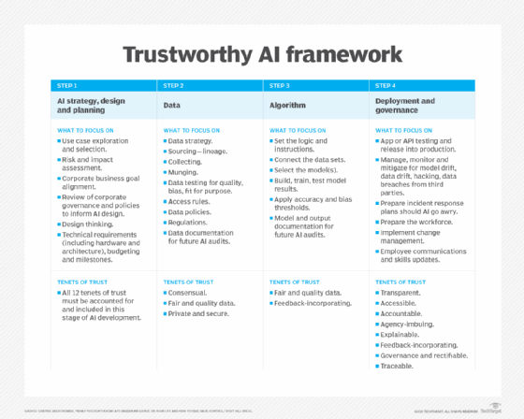
Figure 1. Possible frameworks for responsible AI can differ from company to company.
Implementation can also differ from company to company. For example, the chief analytics officer or other dedicated AI officers and teams might be responsible for developing, implementing and monitoring the organization's responsible AI framework. An explanation of the organization's framework should be documented on the organization's website, listing how it addresses accountability and ensures its use of AI is anti-discriminatory.

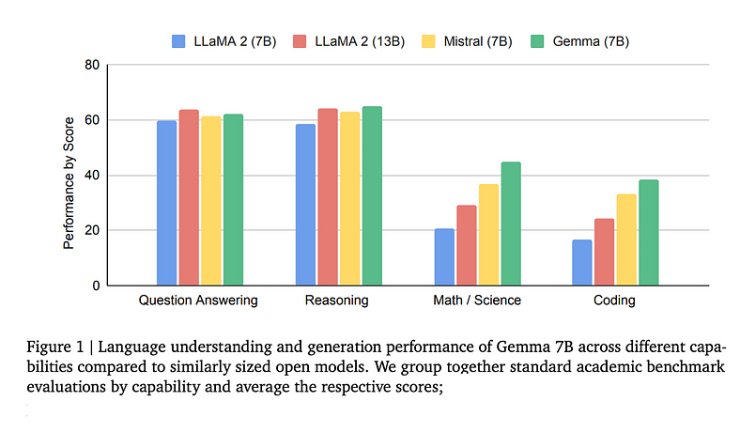
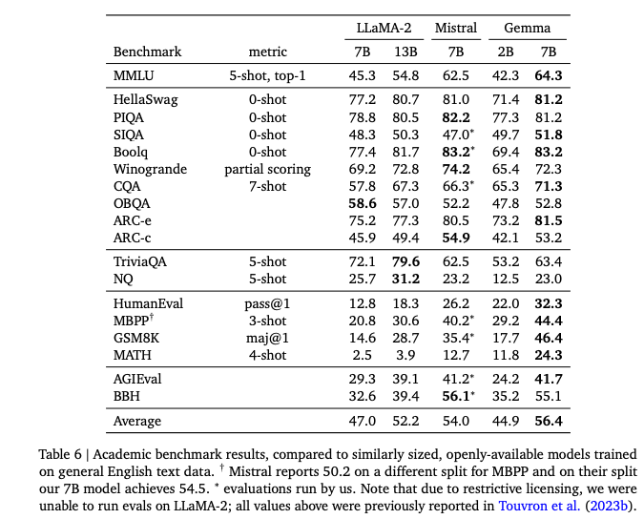
Gemma benefits from many learnings of the Gemini model program including code, data, architecture, instruction tuning, reinforcement learning from human feedback, and evaluations.
Here’s a quick breakdown of their technical paper:
👉 Model Architecture
Based on the original transformer decoder architecture (From “Attention Is All You Need” paper) with the below improvements:
⛳ Multi-Query Attention instead of the original multi-head attention.
⛳ RoPE Embeddings in each layer, sharing them across inputs and outputs to reduce model size.
⛳ GeGLU Activations instead of ReLU
⛳ Normalizer Location: Normalizes both input and output of each transformer sub-layer using RMSNorm.
The original Transformer decoder architecture proposed in the "Attention Is All You Need" paper, with several key improvements:
1. **Multi-Query Attention**:
- In the original Transformer architecture, the multi-head attention mechanism computes attention scores based on a single query matrix. In this variant, the model uses multi-query attention, where multiple query matrices are used to compute attention scores. This allows the model to capture richer relationships between tokens in the input sequence.
2. **Relative Positional Encodings (RoPE) Embeddings**:
- Traditional Transformers use absolute positional encodings to provide information about the position of tokens in the input sequence. RoPE embeddings are an enhancement that introduces relative positional information into the embeddings. These embeddings are shared across both the input and output layers of the model, reducing the overall size of the model while still preserving important positional information.
3. **GeGLU Activations**:
- Instead of using the Rectified Linear Unit (ReLU) activation function, this variant employs the Gated Gaussian Linear Unit (GeGLU) activation. GeGLU is a variant of the GLU activation function, which combines the outputs of two parallel linear transformations using a gating mechanism. GeGLU activations have been found to be effective in certain natural language processing tasks.
4. **Normalizer Location**:
- The model uses RMSNorm as the normalization technique, which is applied to both the input and output of each transformer sub-layer. RMSNorm is a variant of layer normalization that computes the mean and variance using the root mean square of the activations. This normalization technique helps stabilize the training process and improve the generalization of the model.
Overall, these architectural improvements aim to enhance the performance, efficiency, and generalization capabilities of the Transformer decoder model, making it well-suited for various natural language processing tasks.

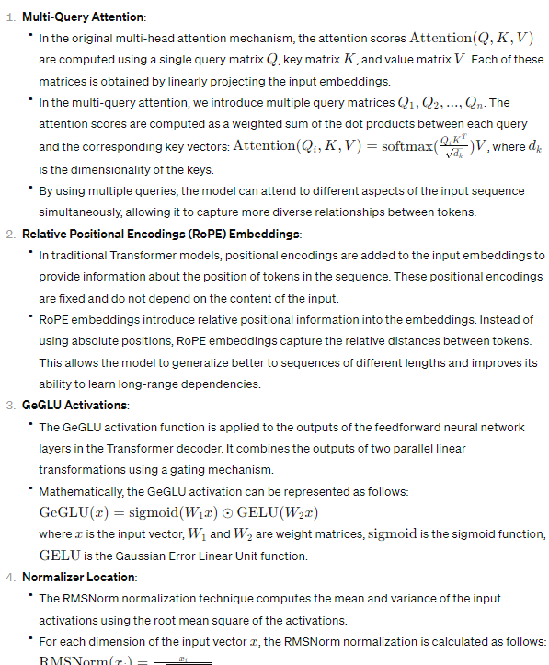
👉Training Data
⛳Trained on English data from web documents, mathematics, and code, using a modified subset of the SentencePiece tokenizer from Gemini. Filtering is done to improve alignment.
👉Instruction Tuning
Uses SFT(Supervised Fine-Tuning) and RLHF(Reinforcement Learning from Human Feedback)
⛳SFT: Data mixes are chosen by comparing responses from different models based on human preference. Prompts focus on following instructions and being safe and use automatic judges.
⛳RLHF: Further fine-tuning is conducted by gathering human preferences and training a policy.
The core parameters of the architecture are summarized in Table 1. Models are trained on a context length of 8192 tokens.
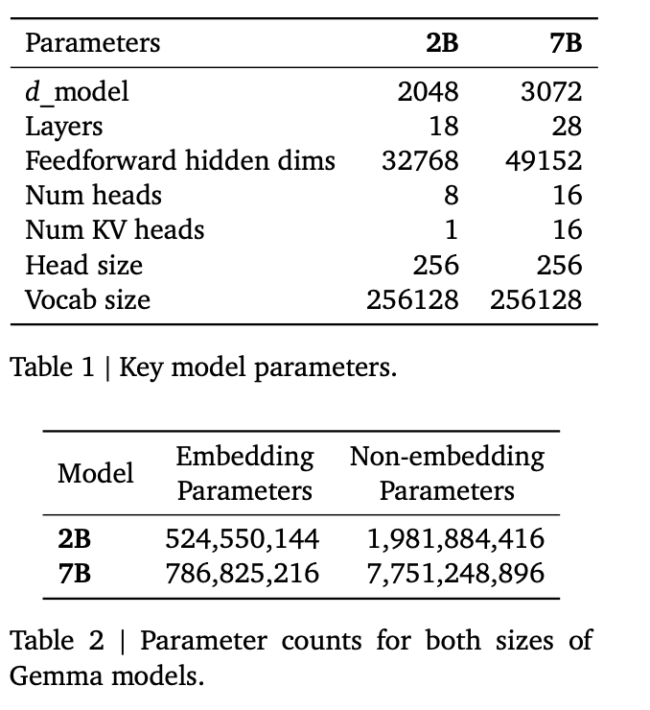
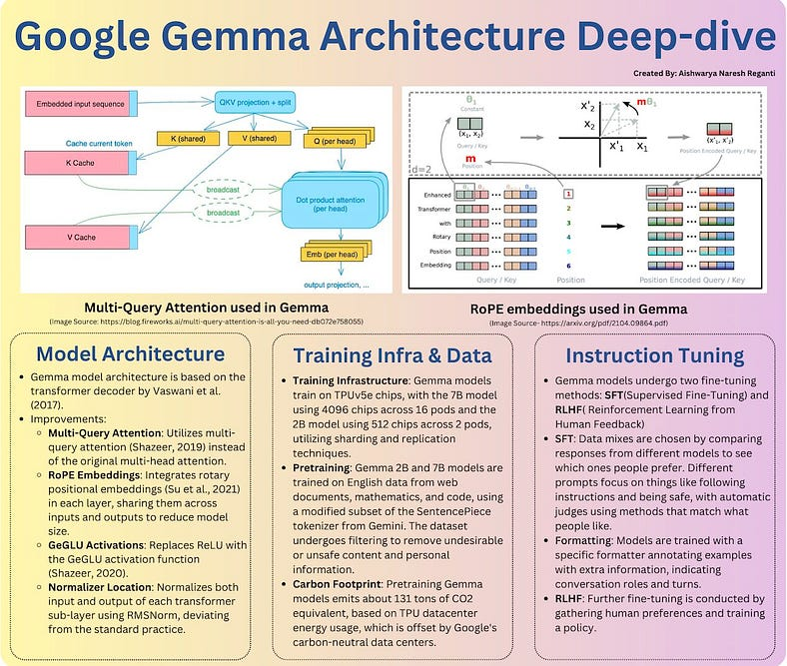
What are some of the interesting design choices behind Gemma?
1) Gemma uses a really large vocabulary and consequently embedding weight matrices.
2) Like OLMo and GPT-2, Gemma also uses weight tying.
3) It even uses GeLU (in the form of GeGLU), similar to GPT-2, unlike Llama 2 and other LLMs.
4) Interestingly, Gemma normalizes the embeddings by the square root of the hidden layer dimension.
5) The RMSNorm layers are in the usual location, different from what was hinted at in the technical paper.
6) However, the RMSNorm implementation comes with the unit offset that wasn’t mentioned in the technical paper.
As mentioned above, its vocabulary size (and consequently the embedding matrix size) is very large. The table below shows an architecture overview comparing Gemma to LLama 2 7B and OLMo 7B.
